**PROJECT REPORT**

**SUBSCRIBERS GALORE**

**EXPLORING WOLRD TOP YOUTUBE CHANNEL**

**TEAM ID :**

**NM2023TMID08656**

**Introduction:**

* 1. **overview:**

**YouTube** is an online video sharing and social media platform headquartered in  California United States. Accessible worldwide, it was launched on February 14, 2005, by   Chad Hurley, and Jawed Karim. It is owned and is the second most visited website in the world. YouTube has more than 2.5 billion monthly users,[]](https://en.wikipedia.org/wiki/YouTube#cite_note-8) who collectively watch more than one billion hours of videos every day. As of May 2019, videos were being uploaded to the platform at a rate of more than 500 hours of content per minute.[[](https://en.wikipedia.org/wiki/YouTube#cite_note-500_hours_per_minute-10)

* 1. **purpose:**
* Users can search for and watch videos
* Create a personal YouTube channel
* Upload videos to your channel
* Like/Comment/share other YouTube videos
* Users can subscribe/follow other YouTube channels and users
* Create playlists to organize videos and group videos together
* **YouTube is a free to use service** and a can be a great space for teens to discover things they like. For many young people, YouTube is used to watch music videos, comedy shows, how to guides, recipes, hacks and more. Teens also use the video-sharing service to follow their favourite vloggers (video blogger), subscribe to other YouTubers and celebrities they are interested in.

**2. problem Definition And Design Thinking :**

**2.1 Empathy map:**

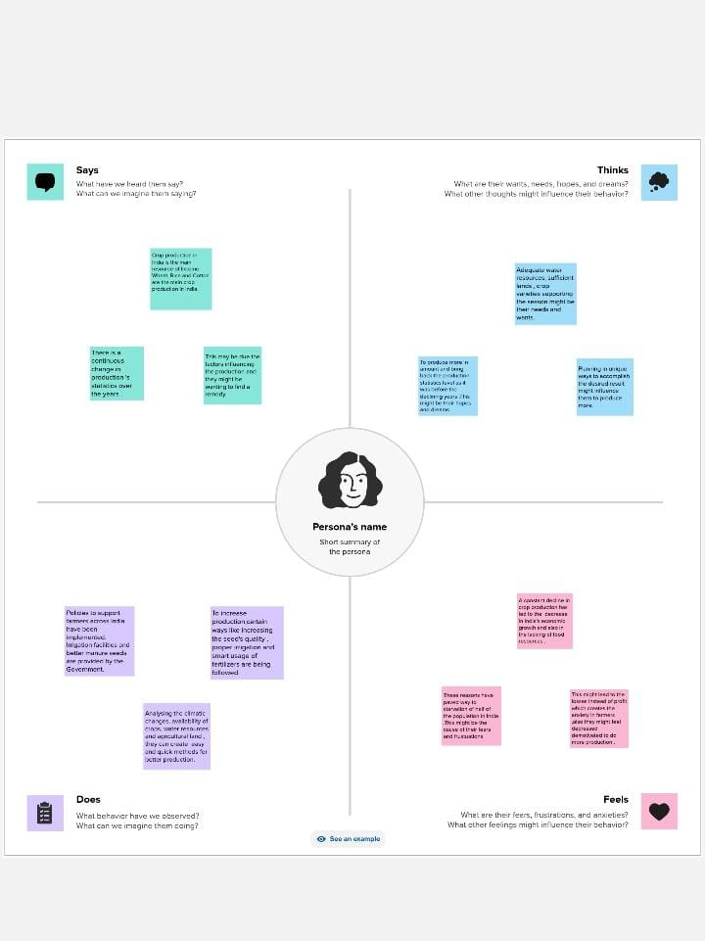

*2.2 Ideation and Brainstorming map :*

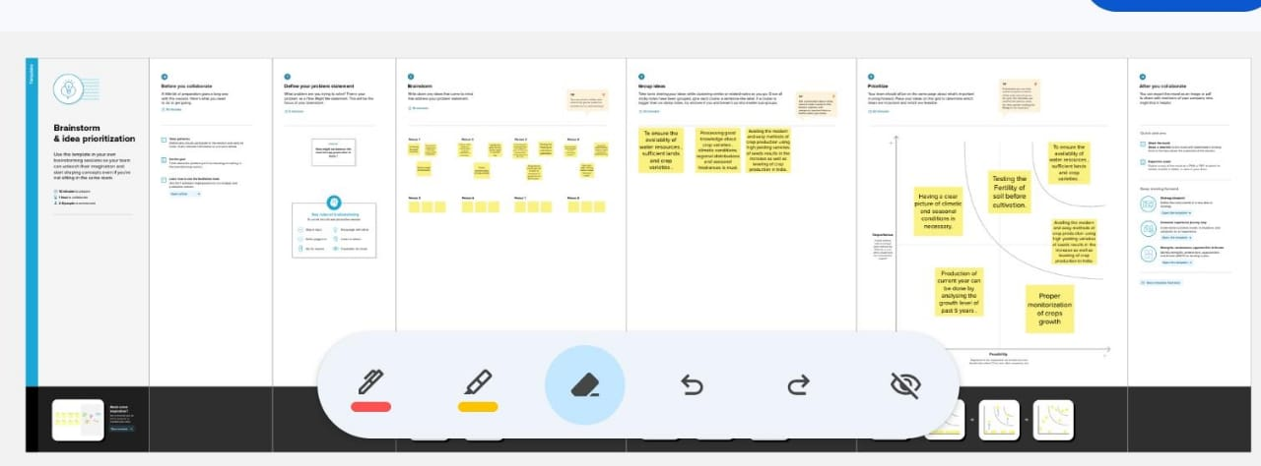

**3. RESULT:**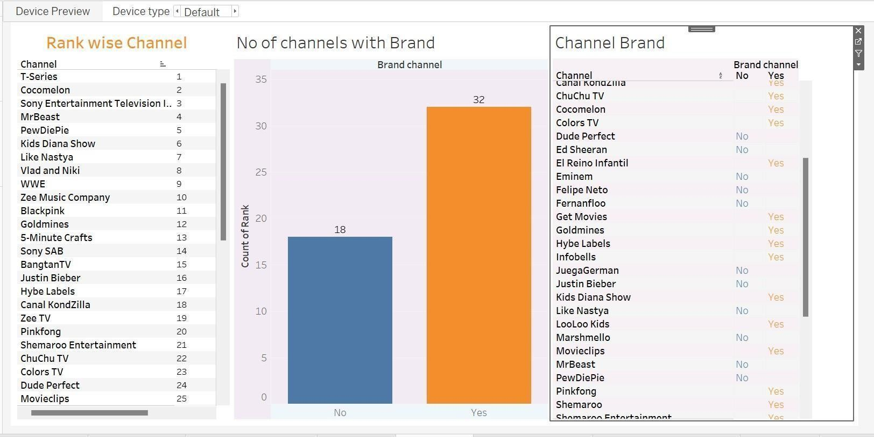

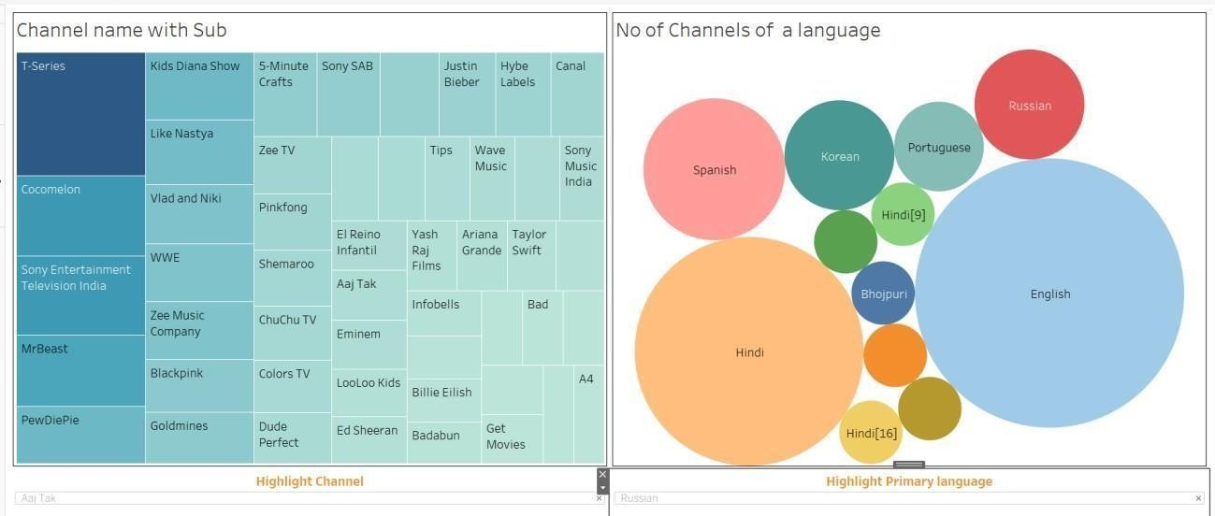

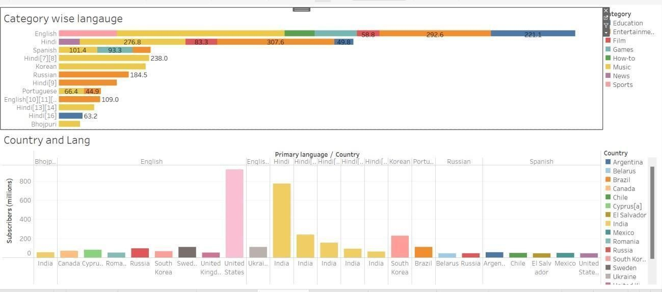

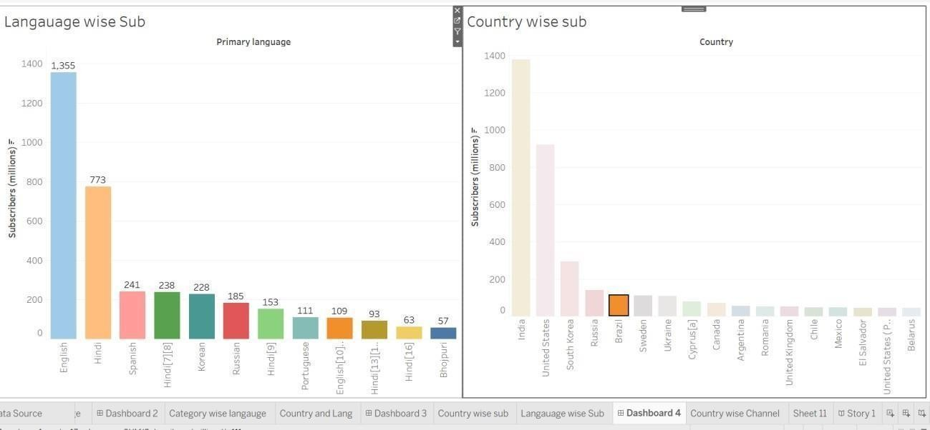

**4.Advantages:**

“YouTube is television for generations. Alphabet  reaches more 18 to 49-year-olds than all linear TV networks combined. This potentially lets you move beyond just direct-response digital advertising, as you can position your business alongside an entertainment brand and get a halo effect for your own brand.

. Solid monetization tools exist once you’re at scale. If your YouTube channel is racking up views, it’s easy to click a button and really start earning money. You don’t have to futz with selling anything, you can focus on creating content and the ads will be inserted automatically for you.

A potentially large audience exists to get to know you, your brand, and your products. People watch more than a billion hours of YouTube video every day! Along with the ads, it’s a useful way to get people to check out your website, potentially sign up for your email list, and more.

5. Disadvantage:

You’re building on rented land with YouTube. That’s mostly fine, but you’re always an algorithm change away from having a successful channel turn into an unsuccessful one. If you can, try to get your YouTube audience over to your owned channels like your website or your email marketing list.

It takes a lot of time and effort to build a large audience. YouTube has a lot of people watching and a lot of people creating.

Breaking through the noise is harder than you think. You can’t just create a few videos and expect to be successful. You have to consistently create amazing content that’s optimized for the algorithms to stand a chance. There’s a reason why the most successful YouTubers do YouTube as their full-time job.

YouTube can lead to burnout. High-profile creators consistently say that YouTube can be demanding. You’re constantly creating more videos and often longer ones, to satisfy an ever-changing algorithm. Creators often have little say in how YouTube changes its algorithm and monetization tools, too.

6. Conclusion:

If you’re anything like me, the hardest parts of writing any paper are the introduction and the conclusion. That’s because, unlike the rest of the paper, where you just write what you have to say: the introduction and conclusion have to influence the way your readers think and feel about what you’re saying.

Good introductions will make your audience want to read what you have to say. Good conclusions will make your audience feel like glad that they read what you had to say. **YouTube is a free to use service** and a can be a great space for teens to discover things they like. For many young people, YouTube is used to watch music videos, comedy shows, how to guides, recipes, hacks and more. Teens also use the video-sharing service to follow their favourite vloggers (video blogger), subscribe to other YouTubers and celebrities they are interested in.

**7.Future Scope:**

1. The YouTube community is one of the most supportive communities in the world.
2. It does this by rewarding creators for their hard work and dedication through upvotes, comments, and subscriptions. The YouTube platform has changed over time to make it easier for content creators.
3. In 2022, YouTube will be the most important social media platform.
4. YouTube is a popular website that allows users to upload and view videos. Over time, YouTube has been evolving its features to improve user experience.
5. In 2022, I expect that YouTube’s video platform will have reached new heights of success.

**THANKYOU**